## Developments in Battery Technology

One company, Graphenano has developed a new battery, called *Grabat*, that could offer a significant improvement in driving range for EV on a single charge.

(GTM, 2017) state that *“According to CEO and President Martín Martínez, Graphenano is producing batteries with energy densities of 1,000 watt-hours per kilogram -- around five times that of current lithium-ion cells. A Tesla Model S equipped with these batteries would increase its range from 334 to 1,013 kilometres, he claimed”*.

## Wireless Charging

Wireless charging research and development is well underway. A solution being developed by the Hevo Power company (Hevo, 2017) provides wireless charging via a mobile phone app, a power device on the ground and a wireless receiver as figure 7 shows.

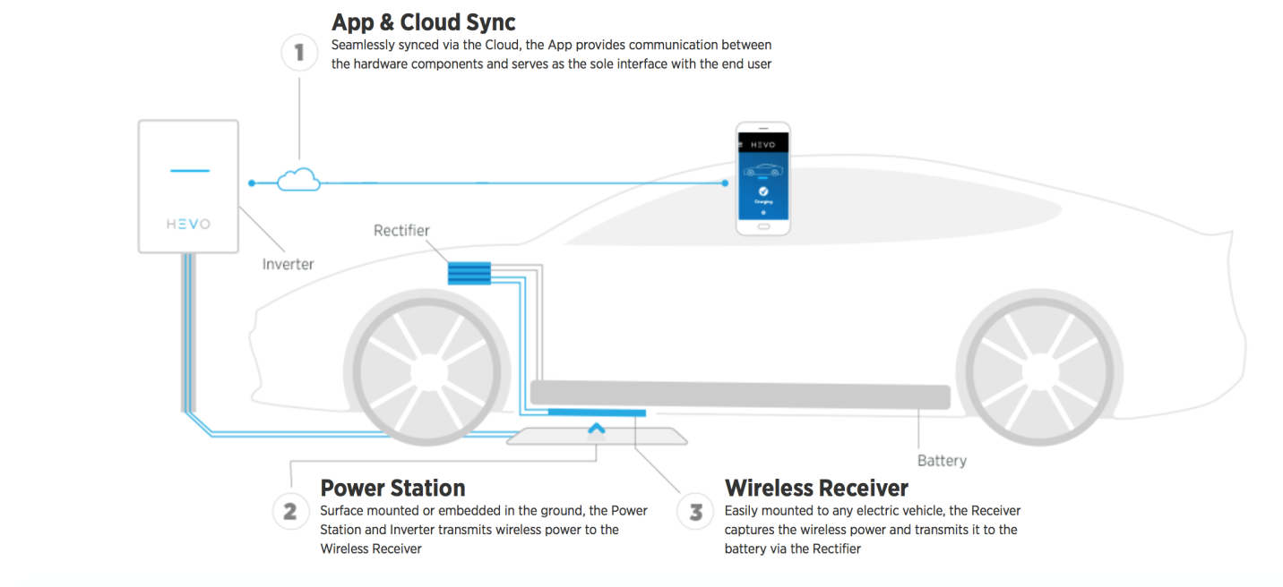

*Figure 7 – Hevo Power wireless charging solution (Hevo, 2017)*

The basic idea around this technology is that it uses two coils made from copper and ferrite which is a magnetic compound. One coil is positioned in the *power station* on the ground, which resembles a manhole cover and the other is positioned under the EV. When the two coils are aligned (via a mobile phone app), electricity in the ground coil *(power station)* creates an electromagnetic field in the gap between the two coils which the coil under the EV absorbs. A *rectifier* then converts this AC electricity into DC to provide a charge for the EV battery. Wireless charging may prove to be a more practical option to charging EV batteries as it employs technologies already established such as *the cloud* (internet) mobile phones and will not require great cultural change. The downside to this technology is that it requires precise vehicle positioning and will not provide a charging solution where motorists use unofficial parking areas such as temporary parking areas.

## Autonomous Charging

Autonomous charging whereby humans do not directly position an EV for recharging is being explored by researchers. In the research conducted by (Perez, et al., 2013) a control architecture for autonomous docking systems, based on an embedded perception system in an autonomous electric vehicle and a recharging station for urban parking areas was considered to be viable. The researchers showed that a visual surveying system coupled with an automatic controller allows the vehicle to dock accurately to the recharging booth in a street parking area. The results show good behaviour such that it is currently deployed as a real prototype system in the city of Paris (Perez, et al., 2013).

# Survey

## Background and Overview

A survey was conducted by myself on the 22nd February 2018 with a purpose of collecting opinions on the views of electric cars.

The survey was created using Google Forms and the survey was referenced in an email link which was sent to all students and staff within UTC Oxfordshire.

The survey was also added the UTC Oxfordshire Facebook page and shared to people outside the UTC.

The survey asked 12 multiple choice questions ranging from personal details of the participant to questions around preferences relating to electric vehicles.

The survey was closed on the 15th March 2018 with survey data captured from 206 respondents.

## Purpose

The survey was used to gain insights into the opinions of a diverse range of people from the ages of 13 to 70.

## Analysis

The data was analysed to produce the following insights:

* Fuel preferences across the age categories of teenagers (13-18), 20-40 and 40+ of people who own cars
* Likelihood of buying an electric car
* Perception of there being enough charging points

**Teenager car owners fuel preference**

|  |  |  |  |
| --- | --- | --- | --- |
| **Fuel preference** | **Male** | **Female** | **No Gender Stated** |
| Petrol | 8 | 2 | 0 |
| Diesel | 2 | 0 | 0 |
| Electric | 0 | 1 | 0 |
| Other | 0 | 1 | 0 |

**20-40 car owners fuel preference**

|  |  |  |  |
| --- | --- | --- | --- |
| **Fuel preference** | **Male** | **Female** | **No Gender Stated** |
| Petrol | 4 | 14 | 0 |
| Diesel | 9 | 8 | 0 |
| Electric | 6 | 8 | 0 |
| Other | 5 | 4 | 0 |

**40+ car owners fuel preference**

|  |  |  |  |
| --- | --- | --- | --- |
| **Fuel preference** | **Male** | **Female** | **No Gender Stated** |
| Petrol | 6 | 15 | 0 |
| Diesel | 1 | 11 | 0 |
| Electric | 5 | 6 | 0 |
| Other | 6 | 5 | 0 |
| **Total** | **18** | **37** | **0** |

**Likelihood of buying an electric car**

|  |  |  |  |  |
| --- | --- | --- | --- | --- |
| **Age Range (years)** | **Male** | **Female** | **No Gender Stated** | **Description** |
| Teenagers (13-18) | 2.2 | 5.0 | 0.0 | Average probability (1-10) |
| 20-40 | 3.4 | 3.7 | 0.0 | Average probability (1-10) |
| 40+ | 3.1 | 2.4 | 0.0 | Average probability (1-10) |

**Teenager perception of there being enough charging points**

|  |  |  |  |  |  |  |  |  |  |
| --- | --- | --- | --- | --- | --- | --- | --- | --- | --- |
| **Category** | **Male** | | | **Female** | | | **No Gender Stated** | | |
| Analysis | Yes | No | Not Sure | Yes | No | Not Sure | Yes | No | Not Sure |
| Car owners | 1 | 9 | 0 | 0 | 3 | 0 | 0 | 0 | 0 |
| Non Car owners | 1 | 35 | 5 | 0 | 7 | 1 | 0 | 2 | 2 |
| **Total** | **2** | **44** | **5** | **0** | **10** | **1** | **0** | **2** | **2** |

**20-40 year olds perception of there being enough charging points**

|  |  |  |  |  |  |  |  |  |  |
| --- | --- | --- | --- | --- | --- | --- | --- | --- | --- |
| **Category** | **Male** | | | **Female** | | | **No Gender Stated** | | |
| Analysis | Yes | No | Not Sure | Yes | No | Not Sure | Yes | No | Not Sure |
| Car owners | 3 | 17 | 2 | 5 | 47 | 14 | 0 | 0 | 0 |
| Non Car owners | 0 | 2 | 0 | 0 | 4 | 1 | 0 | 0 | 0 |
| **Total** | **3** | **19** | **2** | **5** | **51** | **15** | **0** | **0** | **0** |

**40+ perception of is there being enough charging points**

|  |  |  |  |  |  |  |  |  |  |
| --- | --- | --- | --- | --- | --- | --- | --- | --- | --- |
| **Category** | **Male** | | | **Female** | | | **No Gender Stated** | | |
| Analysis | Yes | No | Not Sure | Yes | No | Not Sure | Yes | No | Not Sure |
| Car owners | 1 | 18 | 3 | 2 | 30 | 11 | 0 | 0 | 0 |
| Non Car owners | 0 | 1 | 0 | 0 | 2 | 0 | 0 | 0 | 0 |
| **Total** | **1** | **19** | **3** | **2** | **32** | **11** | **0** | **0** | **0** |

## 

## Conclusions from the Survey

**Teenagers**

Amongst car owning teenagers, it appears that the following is evident:

Females prefer electric cars to males within this age group, whereas males prefer petrol

Females are more likely to buy an electric card than males in this group

Both females and males strongly agree that there are not enough electric charging points and this is the opinion for both car and non-car owners within this group

**Age group 20-40**

Car owning males preferred diesel as a fuel type to electric whereas females preferred petrol as their main choice amongst respondents. Electric came joint second with diesel for females as a preferred fuel type.

In terms of the likelihood of buying an electric car, females within this group were more likely than males to do so although there was only a slight difference from a sample of 34 females and 21 males.

Both male’s and female’s car owning and non-car owning respondents agreed that there were not enough electric car charging points available.

**Age group 40+**

Car owning males just preferred petrol over hybrid and electric as a fuel type, whereas females preferred petrol with diesel second amongst respondents. It appears that within this group electric is unpopular.

In terms of the likelihood of buying an electric car, females within this group were slightly likely than males to do so.

Both male’s and female’s car owning and non-car owning respondents agreed that there were not enough electric car charging points available. However, within the female respondents there were many who were unsure on this issue.